June 2020
Regional Transportation Authority Transit Access Citizens’ Advisory Board
Summary of RTA
Regional Response to
COVID-19

Below is a summary of the information shared with transit riders and stakeholders, from approximately March 2020 to late June 2020. Some of the information included is now outdated as events moved quickly. For the most up to date service information about each Service Board, please visit each agency’s individual website: CTA, Metra and Pace.

Transit service and funding was affected by the statewide pandemic-related restrictions imposed by Governor’s Pritzker’s 5-phase Restore Illinois Plan and Chicago Mayor Lori Lightfoot’s restrictions, which were not always completely aligned. In addition, during the end of May and beginning of June, ridership was further affected by protests tied to the death of George Floyd while in police custody in Minneapolis. We at the RTA watched the events In Minneapolis with heavy hearts and great sadness. We will continue to work to ensure that the RTA is a workplace that promotes inclusiveness, openness and equity. Like other organizations, the RTA is taking this opportunity to further discuss and examine diversity at our agency.
The RTA has created a document called Ready to Ride? that highlights what all three Service Boards are doing to ensure it’s safe to ride transit again when riders are ready. The flier also reminds riders what they should do to remain safe, such as wear masks and socially distance on trains and buses.
The RTA also launched a new online dashboard with information about effects of the COVID-19 pandemic on the region’s transit network. The dashboard can be found on the agency website, RTAChicago.org. The RTA is sending regular e-mail communications about the COVID-19 pandemic, recovery, and effects on the transit system. Sign up to receive those e-mails here.
Now, the summary of RTA and regional transit service since March 2020:

Summary of RTA and Regional Transit Response to COVID-19

RTA Background
The Regional Transportation Authority (RTA) is responsible for financial oversight, funding, and regional transit planning for the three transit operators in Northeastern Illinois: the CTA, Metra and Pace (known as the three “Service Boards”). During normal operating conditions, the regional transit system provides nearly two million rides per weekday with 7,200 transit route miles throughout Northeastern Illinois. On an average weekday before the pandemic, nearly two-thirds of all individuals arriving in Chicago’s Loop traveled on a train or bus. The RTA region covers a six-county geographical area that includes the following counties in Northeastern Illinois: Cook, DuPage, Lake, Will, Kane, and McHenry.

RTA Program Changes
Due to COVID-19, RTA customer service offices are closed, and no services are currently being provided at any of the RTA’s Customer Service Locations. Until further notice, please do not travel to any of these sites for assistance. Help is available by phone and more information can be found at https://www.rtachicago.org/rider-resources.

Reduced Fare and Ride Free Programs
For customers who have a Reduced Fare permit that has expired or will expire during the pandemic, the RTA will be extending a one-time courtesy of automatically renewing eligibility so these customers can continue access reduced fares without needing to take action to renew. A new permit will come in the mail prior to the expiration of the current permit.

For customers who have a Ride Free permit that has expired or will expire during the pandemic, the RTA will automatically renew Ride Free Permits for those individuals who are currently eligible for the State of Illinois Department on Aging’s Benefit Access Program (BAP) and mail them prior to the expiration of the current permit. For those customers who are not currently enrolled in the Illinois Department on Aging’s BAP, the RTA will extend a one-time courtesy six-month Ride Free permit extension to allow customers the time to renew their BAP eligibility.
Customers who are applying for a Reduced Fare or Ride Free Permit for the first time can visit the RTA website and download a Reduced Fare and/or Ride Free application and follow the directions in the application.
Customers can obtain assistance in applying for a Reduced Fare and/or Ride Free permit, to renew a permit that expires soon, or to replace a lost or stolen permit by calling 312-913-3110 If a permit is being held at RTA’s headquarters located at 175 W. Jackson Blvd, Chicago, customers can call 312-913-3110 for further assistance.

RTA Travel Training Program
The RTA is temporarily canceling all scheduled Travel Training sessions with customers. If a customer is interested in participating in Travel Training when the program resumes, or have questions about the program, they can call 312-663-HELP (4357).

ADA Paratransit Certification Program
The RTA’s South and Northwest Chicago Mobility Assessment Centers are currently closed and will not be performing interviews and assessments for ADA Paratransit Certification until further notice.

For all customers whose ADA paratransit certification has expired or will expire during the pandemic, the RTA is extending a one-time courtesy six-month extension of eligibility.
Customers who are applying for ADA paratransit eligibility for the first time can call the Mobility Services Helpline at 312-663-HELP (4357) and inform the customer service representative that they are interested in applying for ADA paratransit service. A phone interview will be scheduled to discuss eligibility. New customers will be given a six-month temporary eligibility and will be required to come to one of the RTA ADA Mobility Assessment Sites in the future to complete an in-person interview and assessment for on-going eligibility.
Customers may obtain further information or ask additional questions by calling the RTA’s Mobility Services Helpline at 312-663-HELP (4357).

Call Center and ADA Certification Changes Due to COVID-19 Impacts Through June 11, 2020
Staff is tracking call center activity for the ADA, Travel Information Center (TIC), and Fare Programs Call Centers to evaluate the extent that call center activity has changed during the COVID-19 pandemic crisis. Data is shown as a percentage change compared to a “normal” pre-COVID activity week of March 9-13, 2020. Figure 1 illustrates the significant drop-off in call center volumes leading up to the Governor’s Stay-at-Home order implemented on March 21, followed by sustained low levels throughout the reporting period. Recent upticks have been seen for each type of call center activity: the TIC call volume increased 38 percent, Fare Program calls increased 39 percent, and the ADA call volume increased 36 percent for the week June 1-5. However, each call center volume remained lower compared to early March: TIC calls were at -10 percent, Fare Program calls were at -40 percent, and ADA calls were at -60 percent. In addition to call center activity, the chart also shows systemwide ridership trends over the same time period, which has maintained steeper decreases throughout the report period.

Figure 2 shows the percent change in the number for ADA certifications, also in comparison to the week of March 9, 2020. The week of June 1-5 saw a near doubling of certifications from the prior week, from 95 to 186, yet remained 12 percent below early March levels.

Figure 3 illustrates the number of ADA certification extensions that were provided to customers automatically as an alternative to the traditional in-person recertification process. March and April saw significant numbers of extensions of 1,478 and 2,369, respectively. May data show a significant decline to 238 extensions. Staff will continue to monitor and report on all three call center volumes, as well as ADA certifications and extensions, as requested.
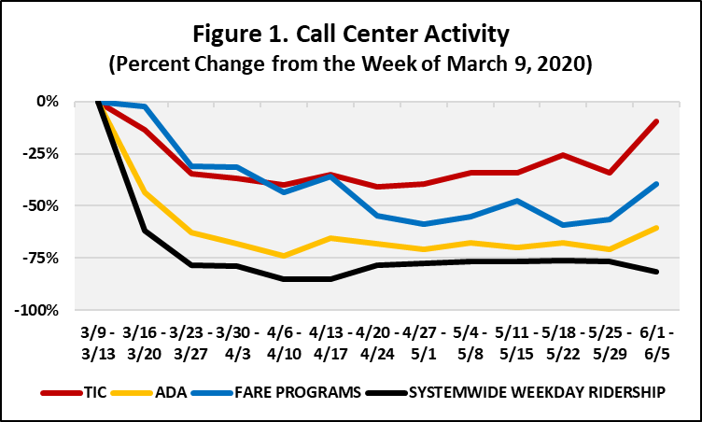
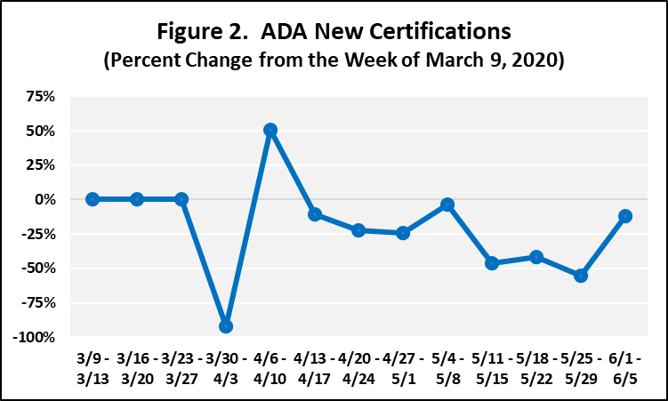

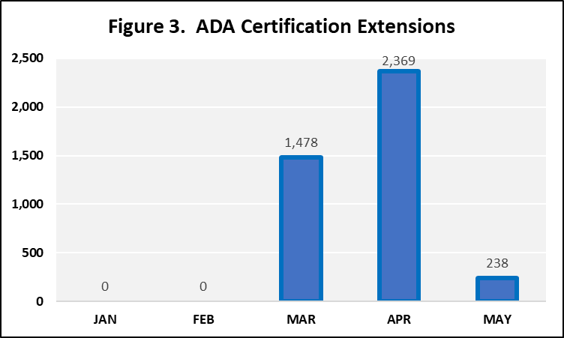

Financial Impact of COVID-19 on Regional Public Transportation

Brief Overview of RTA Funding Structure
Funding for the region’s transit system is derived from a combination of several local, state, and federal sources. The daily operation of buses and trains in the region is funded through:
- System generated revenue, consisting mostly of fare revenue
- The regional RTA sales tax (In 2019, generated approximately $1.254 billion).
- A portion of the real estate transfer tax imposed within the city of Chicago and
- State operational funding (17.6percent of the system’s operational budget).
The cost to maintain, rehab, and replace the region’s capital infrastructure is funded through:
- Federal formula and discretionary fund: 41 percent
- Dedicated state capital funding: 14 percent
- State bond programs: $2.7 billion in additional state capital funding.

Long-term Financial Impact
The RTA and Service Boards are in the process of developing a long-term financial impact outlook associated with the COVID-19 pandemic. The significant decrease in ridership will certainly have a negative impact on fare revenue for each of the Service Boards during the remainder of this fiscal year and likely beyond. The general downturn in the economy will undoubtedly have an impact on the RTA sales tax, the real estate transfer tax, the statewide motor fuel tax, and the RTA’s state funding, which is tied by formula to sales tax revenue.
The Illinois General Assembly met on in late May to pass essential legislation. On May 24, the legislature passed a $42 billion FY 2021 state budget despite the fact that FY 2021 state revenue projections estimate that less than $37 billion of state revenue will be available during FY 2021. To bridge the gap between anticipated revenue and budgeted expenditures, the state plans to borrow from the Federal Reserve Bank under the Municipal Liquidity Facility Program established pursuant to the CARES Act and the Federal Reserve Act. The program allows state and local governments to borrow from the Federal Reserve to “meet the failures of revenue resulting from the COVID-19 outbreak.” Pursuant to the federal legislation, the loan can be repaid on a long-term basis. The Illinois General Assembly passed legislation that would authorize the state to borrow up to $5 billion from the federal program. Legislative leaders have stated that the state would borrow less from the program if the federal government passed additional COVID-19 relief funding in the future.
The state fiscal year 2021 operating budget contained funding levels for the RTA region consistent with state fiscal year 2020 budget, including a 5 percent Public Transportation Fund (PTF) reduction for FY 2021. Additionally, the budget contained a $17.57 million reduced fare reimbursement, a $8.394 million ADA paratransit grant appropriation and $131 million in Statewide Community Infrastructure Program (SCIP) bond reimbursement appropriations.
In addition, the region has obtained approximately $1.4 billion in supplemental funding through the federal Coronavirus Aid, Relief, and Economic Security (CARES) Act passed in March. The long-term costs associated with COVID-19 have the potential to exceed this one-time supplemental funding infusion.

Regional Ridership Impact
RTA staff is monitoring preliminary ridership data reported by CTA, Metra, and Pace to determine the extent to which ridership has changed compared to 2019. This data is shown in the chart below. You can see that ridership was relatively normal for all modes in early March, then dropped suddenly through late March as businesses and schools were shutting down. This phase was followed by sustained low levels of ridership for each Service Board. As of June 11, transit ridership was down 76 percent systemwide.

Ridership status compared to 2019

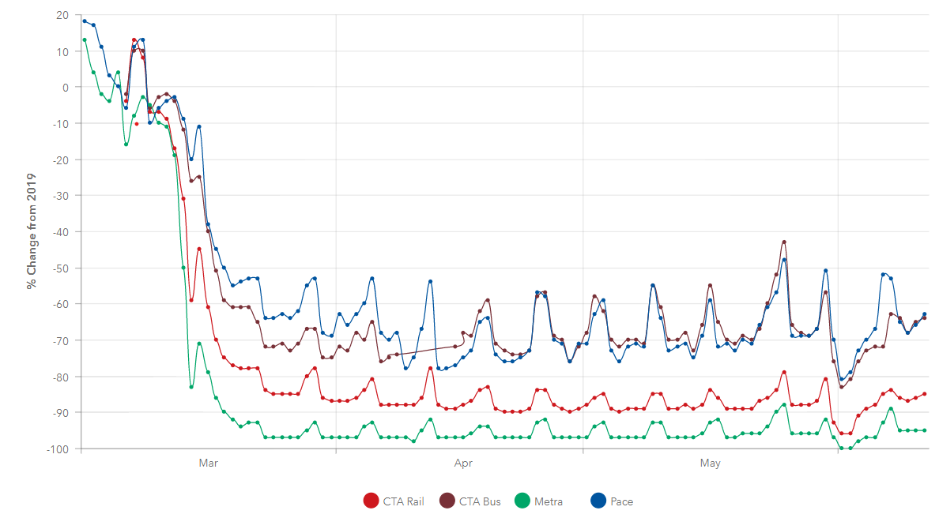

Regional Transit Health and Safety Preventative Measures
The RTA and the Service Boards are committed to passenger and worker safety during this ongoing crisis. To that end, all agencies have worked closely with the Chicago Department of Public Health (CDPH) and Illinois Department of Public Health (IDPH) while continuing to monitor information from the Centers for Disease Control and Prevention (CDC) and the World Health Organization.

Below are the safety and cleanliness measures being taken by each Service Board.

CTA COVID-19 Response and Service Changes
Notices have been posted in CTA buses, rail cars, and stations to remind everyone of the importance of social distancing wherever possible. CTA is following a rigorous cleaning schedule for all buses and trains, which includes both daily cleanings and routine deep cleans. Each vehicle receives multiple cleanings throughout the day, which includes disinfecting surfaces (seats, handrails, stanchions, etc.) and more-concentrated spot cleanings as needed. Every rail station is cleaned throughout the day, which includes disinfecting surfaces such as handles, handrails, Ventra vending machines, faregates, and turnstiles.
CTA has provided all employees with gloves and hand sanitizer and has distributed extensive information to all work locations about COVID-19 and the best practices recommended by city, state, and national health experts.
While operating trains, rail operators are in entirely enclosed operating cabs at the front of the train. Rail station attendants are conducting work out of enclosed kiosks in train stations.
CTA has ensured that the buses on the street during this pandemic are equipped with a protective shield that creates a barrier between the bus operators and their riders.
On April 9, 2020, the CTA announced a new rear-door boarding policy as part of ongoing efforts to protect the health and safety of transit customers. The policy was designed to promote social distancing among customers and CTA bus operators. As of June 22, the CTA was asking all riders to board in the front of buses and pay fares again.
CTA is also introducing bus crowding management, giving bus operators authority to run as “drop-off only” and bypass certain bus stops if their bus is becoming crowded. To determine when to implement bus crowding management, operators will use the guideline of 15 or more passengers on a standard 40-foot bus and 22 or more passengers on a 60-foot bus. In mid-June, CTA added a dashboard to its website to let passengers know when buses on all 127 routes are too crowded to allow for social distancing. Passengers were encouraged to wait for less crowded buses.
There are currently no service modifications being made for any CTA train or bus route. All CTA trains and buses will continue to operate on normal daily schedules. CTA offered a one-time, limited credit for riders with activated 7- and 30-day passes. Eligible customers received a transit value credit reflecting the remaining value of their 7- or 30-day pass, based on the last day it was used. Transit value can be used to pay per ride or toward the future purchase of another unlimited rides pass. Riders needed to request this credit prior to April 13, 2020.
To allow for fare payment, CTA is moving farecard readers (tap devices) to the rear doors of buses. While a number of buses already have the readers at their rear doors, more buses will receive them in the coming weeks. During the transition, CTA will not enforce fare payment on buses that do not yet have rear-door farecard readers.

Metra COVID-19 Response and Service Modifications
Metra has announced that it will be closing off the cab car on all trains to protect its train crews during the pandemic. The cab car is the car furthest from the locomotive. The policy was implemented with safety in mind as it will limit the opportunities for Metra’s train crews to be potentially exposed and will limit passenger exposure. Metra riders have been notified of this adjustment by announcement on the trains. Metra is also prohibiting riders from gathering in the vestibules of trains when the train is approaching stations or terminals.
Metra continues to clean cars every day, with a concentration on disinfecting high-touch areas such as handrails, armrests, and doors. Metra is bringing in extra crews on weekends, when most cars are not in use, to do additional cleaning and disinfecting of cars and locomotives.
Metra is also cleaning Metra-maintained stations multiple times a week, while paying special attention to disinfecting high-touch surfaces. They have purchased steam cleaners to deep clean rail cars. They are also bringing in extra crews to increase the cleaning and disinfecting of downtown stations and have asked municipalities or other entities that maintain the stations in their communities to do the same.
Metra has also added to their inventory of hygienic supplies — including hand sanitizers, sanitizing wipes, and disinfectants — so employees have ample amounts of these essentials.
Metra has moved to an “Alternate Schedule,” which is the same one Metra has implemented in the past when either weather or service disruptions do not allow for operation of regularly scheduled services. The Alternate Schedule still largely allows Metra to run trains within the same hours of operation as its current schedule.
Despite the reduction in service, levels of service are sufficient to meet the needs of current ridership numbers. On a line-by-line basis, Metra is monitoring ridership and may further reduce service based on ridership demand.
Metra resumed accepting cash as payment for fares at ticket windows and on trains on June 1, however it strongly encourages passengers to buy their tickets with the Ventra app to limit interactions between crews and passengers. Buying Metra’s new $10 All-Day Pass on the app will give passengers a “Touch Less, Pay Less” option to ride trains safely and affordably. The All-Day Pass will be good for unlimited rides on all Metra lines all day until 3 a.m. the next morning.
Metra also announced that doctors, nurses, EMTs, paramedics and other medical personnel on the front lines of the coronavirus pandemic will now be able to ride free on Metra trains for the duration of the state’s stay-at-home order. Medical personnel only need to present a work ID showing that they are employed at a hospital, doctor’s office, medical facility, or local fire department to a Metra conductor. For more information see Medical Personnel Ride Free.

Pace COVID-19 Response and Service Modifications
In order to help stop the spread of COVID-19 and limit operator-passenger interaction, Pace announced implemented a “Quick Board, Safe Board” policy and waived fare collection on fixed route bus and ADA paratransit service in March, April, and May.
As of June 22, all riders will be required to pay fares on all Pace bus routes, On Demand services, Dial-a-Rides, and ADA Paratransit services. To support efforts to continue to schedule single-passenger ADA Paratransit trips as ridership allows, we will waive fares on City of Chicago Taxi Access Program (TAP) trips until further notice. Rear-door boarding on bus routes will no longer be permitted.
Pace drivers can no longer physically assist passengers except to secure mobility devices upon request. This is a temporary policy that will remain in place for the duration of the Governor's stay-at-home order. Operators are not able to physically help passengers board or exit a vehicle, carry bags, or travel to and from their door. Passengers who need physical assistance while traveling are encouraged to bring a personal care attendant (PCA) with them. There is no charge for PCAs accompanying passengers.
Pace has also added new steps to its daily vehicle cleaning process. In addition to regular cleaning, Pace employees now apply disinfectant spray to all major touchpoints on the bus.
Operators are being equipped with hand sanitizer and disinfectant wipes, and notices reminding passengers to follow CDC guidelines are being posted to each bus and uploaded to the audio alert system. Thermometers are being provided to front line employees to take temperatures before reporting to work.
Due to the small nature of paratransit vehicles, Pace is working to provide individual trips on ADA Paratransit to promote social distancing.
Pace has suspended service on most of its Metra commuter feeder routes and shuttle bugs. Pace will redeploy resources and equipment to several routes that are still maintaining consistent ridership to ensure that there are no more than 14 passengers on any bus in order to ensure proper social distancing. For more information, please see Pace’s passenger notices.
Pace implemented free rides on Pace fixed route bus and On Demand services to all medical personnel, including doctors, nurses, EMTs, and paramedics, for the duration of the state's stay -at-home order. To ride free, medical personnel must present a work ID showing that they are employed at a hospital, doctor's office, medical facility, or local fire department.
Pace is also waiving the $3 City of Chicago Taxi Access Program (TAP) fare. Riders are still required to swipe their TAP card at the end of their trip, but no money is taken from their account. Riders are still responsible for any taxi fare amount over $30 and City of Chicago fees. This policy will remain in place indefinitely.

Conclusion
The RTA and Service Boards remain committed to continuing to update elected officials and stakeholders across the region and state as the response to COVID-19 continues to unfold. The RTA will be providing updates regarding ridership and revenue data as it becomes available.

